**Single vesicle intensity and colocalization detection**

***A program guide***

1. Acquire 2-channel images and save as a stack file in .tif format.
2. Open Main_SingleVesicleDetectionAndColocalization in MATLAB 2020b and press run. Make sure that you have all functions in the open folder in the directory.
3. A prompt will appear where you set the parameters of the image.

|  |  |
| --- | --- |
| Full image rows | Number of rows in input image |
| Full image columns | Number of rows in input image |
| Number of channels | Number of channels (2) |
| Channel size rows | Number of rows in one channel |
| Channel size columns | Number of rows in one channel |
| cropUp | How many rows to crop on top of the channel |
| cropLow | How many rows to crop on the bottom of the channel |
| cropLeft | How many columns to crop on the left side of the channel |
| cropRight | How many columns to crop on the right side of the channel |
| pixA | Imaged pixel area |
| x_shift | Search area for colocalized spots on, x columns on each side of the center column |
| y_shift | Search area for colocalized spots, y rows above and below the center row |
| threshold bleedthrough | Intensity threshold for bleedthrough |

1. Choose if you want intensity compared colocalization, and which side(s) you want to compare to. No, means that only position compared colocalization is executed.

1. Choose if you want to use drift-correction. If not, define the offset between the channels.

1. A prompt where you can browse for the correct folder will appear. Choose folder.
2. The program will now continue to analyze the first image using the default settings. After a couple of seconds, you get an image where found vesicles are circled red. You will also see a prompt where you can choose to change settings, i.e. you can change SNR for the different channels, vesicle min and maximum sizes, and adjust the relative intensity of the image.

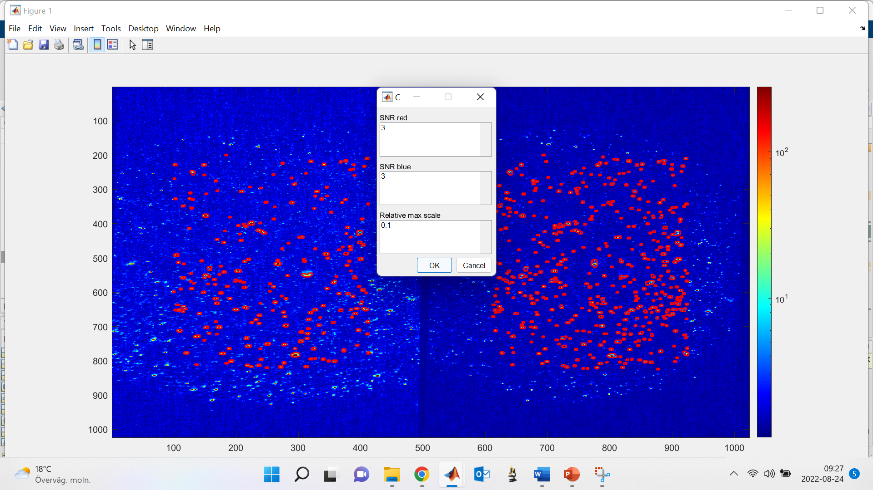

1. Change the values of interest, press ok. You’ll now get a second prompt asking if it needs to update. If you have changed values, press yest, and the program will reanalyze the image and present the new results. If you have not changed values, press no.

1. As soon as you are satisfied with your input values, and presses “no” on update, the program will colocalize vesicles within the image. The result will be presented in a similar image with large white rings circling the colocalized vesicles. If there are no colocalized vesicles, you will instead get a prompt that tells you this. The prompt will ask you “Continue?” after the first image. If you press “no” you’ll quit the program and if you press “yes” you will continue.

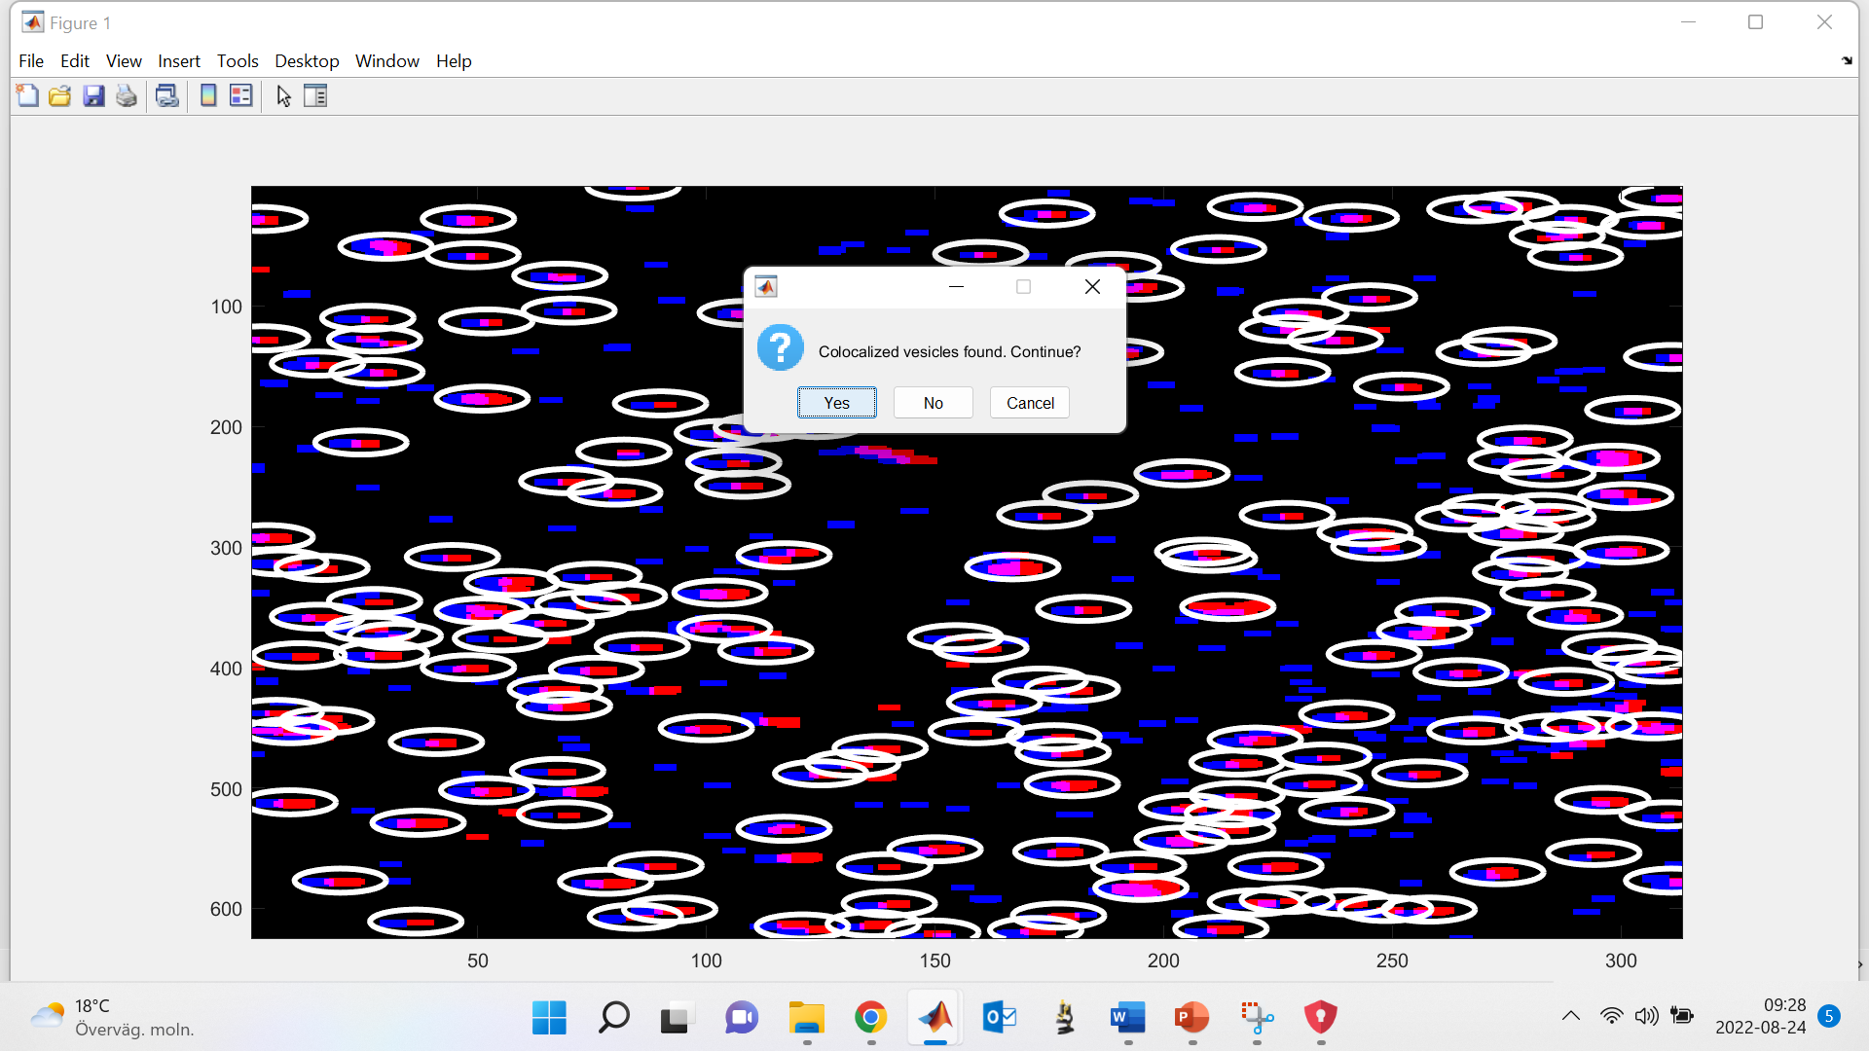

1. You will now get the choice to continue interactively, i.e. repeat the process in step 7-9 for the second image. If you have want to use the same SNR and rel_max for the rest of the stack, press “no”. The program will then continue to analyze the images without showing you the figures in step 7-9 and without the possibility to change parameters.

1. When all images are analyzed, you’ll get up a prompt where you can save the Matlab workspace as a .mat-file, (i.e. all variables).